Rhombus Diagonal Theorem

Definition
# Source: AI Source: Provided by: [Data Path: Persons Table -> ID Column: 1, Name_En Column: Motasem Essam] -> From: [ChatGPT] on [7/25/2026]
The Rhombus Diagonal Theorem states that the diagonals of a rhombus have several important properties:
- The diagonals bisect each other.
- The diagonals are perpendicular.
- Each diagonal bisects a pair of opposite angles.
For rhombus $ABCD$, let diagonals $\overset{‾}{AC}$and $\overset{‾}{BD}$intersect at $O$.
Then:
$$\boxed{AO=OC} \\ \boxed{BO=OD} \\ \boxed{AC⊥BD}$$
and:
$$\boxed{∠BAC=∠CAD} \\ \boxed{∠ABD=∠DBC}$$
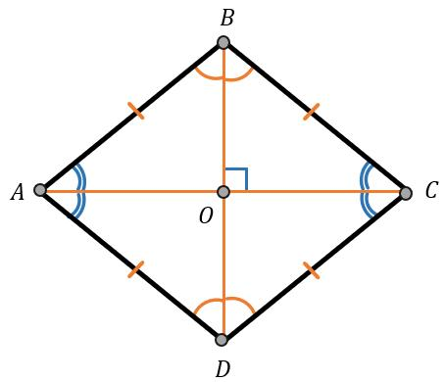
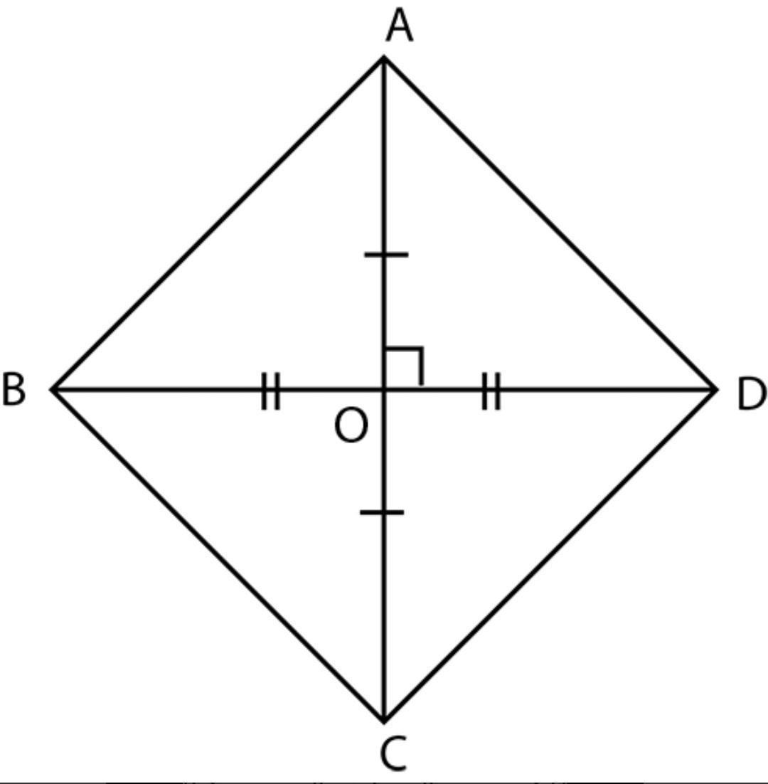
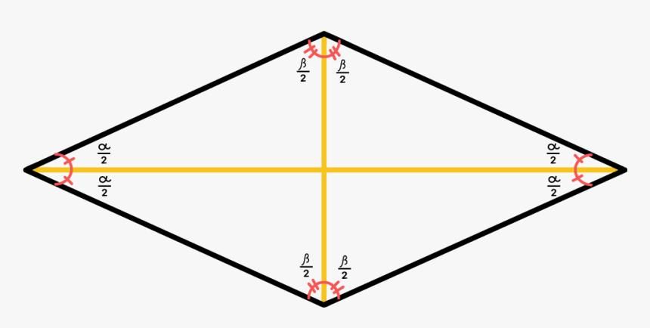
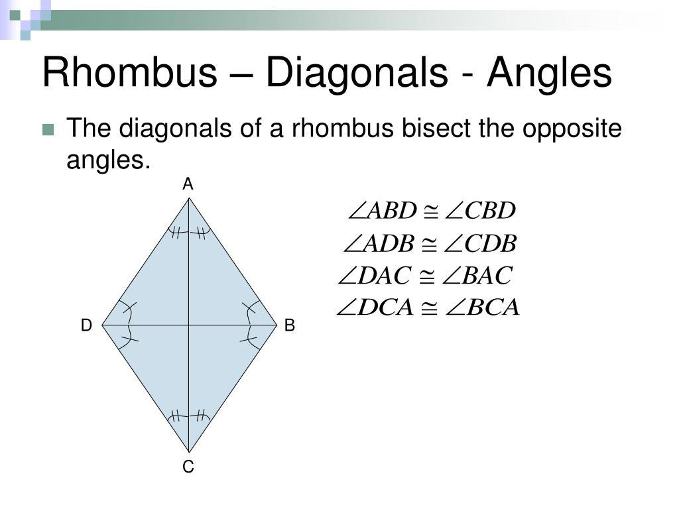
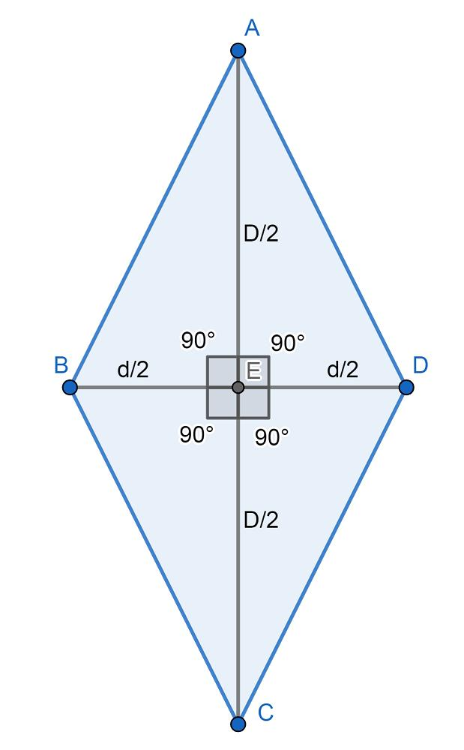

1. Diagonals Bisect Each Other
# Source: AI Source: Provided by: [Data Path: Persons Table -> ID Column: 1, Name_En Column: Motasem Essam] -> From: [ChatGPT] on [7/25/2026]
A rhombus is a special type of parallelogram.
Therefore, its diagonals bisect each other.
If $AC$and $BD$intersect at $O$:
$$\boxed{AO=OC}$$
and
$$\boxed{BO=OD}$$
Thus, $O$is the midpoint of both diagonals.

2. Diagonals Are Perpendicular
# Source: AI Source: Provided by: [Data Path: Persons Table -> ID Column: 1, Name_En Column: Motasem Essam] -> From: [ChatGPT] on [7/25/2026]
The diagonals of a rhombus intersect at a right angle:
$$\boxed{AC⊥BD}$$
Therefore:
$$\boxed{∠AOB=∠BOC=∠COD=∠DOA={90}^{∘}}$$
This is a property that distinguishes a general rhombus from a general parallelogram.

3. Diagonals Bisect Opposite Angles
# Source: AI Source: Provided by: [Data Path: Persons Table -> ID Column: 1, Name_En Column: Motasem Essam] -> From: [ChatGPT] on [7/25/2026]
Diagonal $AC$bisects angles $A$and $C$:
$$\boxed{∠BAC=∠CAD}$$
and:
$$\boxed{∠BCA=∠ACD}$$
Diagonal $BD$bisects angles $B$and $D$:
$$\boxed{∠ABD=∠DBC}$$
and:
$$\boxed{∠ADB=∠BDC}$$
Therefore, each diagonal bisects the two opposite angles through which it passes.

Proof of Perpendicular Diagonals
# Source: AI Source: Provided by: [Data Path: Persons Table -> ID Column: 1, Name_En Column: Motasem Essam] -> From: [ChatGPT] on [7/25/2026]
Consider rhombus $ABCD$, where:
$$AB=BC=CD=DA$$
Since it is a parallelogram, its diagonals bisect each other:
$$AO=OC \\ BO=OD$$
Now consider triangles:
$$△AOB$$
and
$$△COB$$
We have:
$$AB=CB$$
because all sides of a rhombus are congruent.
Also:
$$AO=OC$$
and:
$$BO=BO$$
because $BO$is common.
Therefore:
$$△AOB≅△COB$$
by SSS.
Hence:
$$∠AOB=∠BOC$$
But these two angles form a straight angle:
$$∠AOB+∠BOC={180}^{∘}$$
Therefore:
$$2∠AOB={180}^{∘} \\ \boxed{∠AOB={90}^{∘}}$$
Thus:
$$\boxed{AC⊥BD}$$

Diagonal Length Relationships
# Source: AI Source: Provided by: [Data Path: Persons Table -> ID Column: 1, Name_En Column: Motasem Essam] -> From: [ChatGPT] on [7/25/2026]
Because the diagonals are perpendicular and bisect each other, each half-diagonal forms a right triangle.
For example:
$$△AOB$$
is a right triangle.
Therefore, by the Pythagorean theorem:
$$AB^{2}=AO^{2}+BO^{2}$$
Since:
$$AO=\frac{AC}{2}$$
and:
$$BO=\frac{BD}{2}$$
we obtain:
$$AB^{2}={\left(\frac{AC}{2}\right)}^{2}+{\left(\frac{BD}{2}\right)}^{2}$$
Therefore:
$$\boxed{AC^{2}+BD^{2}=4AB^{2}}$$
This is an important formula for a rhombus.

Example 1 — Finding a Diagonal
# Source: AI Source: Provided by: [Data Path: Persons Table -> ID Column: 1, Name_En Column: Motasem Essam] -> From: [ChatGPT] on [7/25/2026]
Suppose a rhombus has side length:
$$AB=10\text{ cm}$$
and one diagonal:
$$AC=12\text{ cm}$$
Using:
$$AC^{2}+BD^{2}=4AB^{2}$$
we get:
$${12}^{2}+BD^{2}=4\left({10}^{2}\right) \\ 144+BD^{2}=400 \\ BD^{2}=256 \\ \boxed{BD=16\text{ cm}}$$

Example 2 — Using the Half-Diagonals
# Source: AI Source: Provided by: [Data Path: Persons Table -> ID Column: 1, Name_En Column: Motasem Essam] -> From: [ChatGPT] on [7/25/2026]
Suppose:
$$AO=6\text{ cm}$$
and:
$$BO=8\text{ cm}$$
Since the diagonals bisect each other:
$$AC=2\left(6\right)=12\text{ cm} \\ BD=2\left(8\right)=16\text{ cm}$$
The side of the rhombus is the hypotenuse of right triangle $AOB$:
$$AB=\sqrt{6^{2}+8^{2}} \\ AB=\sqrt{36+64} \\ AB=10\text{ cm}$$
Thus:
$$\boxed{AB=10\text{ cm}, AC=12\text{ cm}, BD=16\text{ cm}}$$

Area Using the Diagonals
# Source: AI Source: Provided by: [Data Path: Persons Table -> ID Column: 1, Name_En Column: Motasem Essam] -> From: [ChatGPT] on [7/25/2026]
Because the diagonals are perpendicular, they divide the rhombus into four right triangles.
The area can therefore be calculated using:
$$\boxed{A=\frac{d_{1}d_{2}}{2}}$$
where:
$$d_{1}=AC$$
and:
$$d_{2}=BD$$
Thus:
$$\boxed{A=\frac{AC⋅BD}{2}}$$
For example, if:
$$AC=12$$
and:
$$BD=16$$
then:
$$A=\frac{12\left(16\right)}{2} \\ \boxed{A=96{\text{ cm}}^{2}}$$

Important Distinction
# Source: AI Source: Provided by: [Data Path: Persons Table -> ID Column: 1, Name_En Column: Motasem Essam] -> From: [ChatGPT] on [7/25/2026]
The three major diagonal properties should be kept separate:
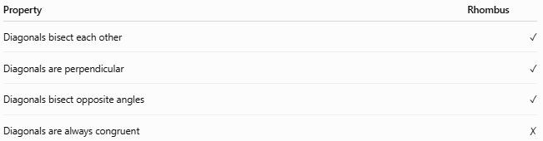
Property | Rhombus
Diagonals bisect each other | ✓
Diagonals are perpendicular | ✓
Diagonals bisect opposite angles | ✓
Diagonals are always congruent | ✗
The last point is important.
A rhombus does not generally have equal diagonals.
Only a square, which is a special rhombus, has both:
$$AC=BD$$
and:
$$AC⊥BD$$

Comparison of Special Parallelograms
# Source: AI Source: Provided by: [Data Path: Persons Table -> ID Column: 1, Name_En Column: Motasem Essam] -> From: [ChatGPT] on [7/25/2026]
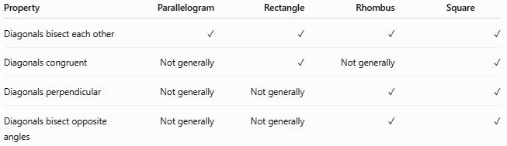
Property | Parallelogram | Rectangle | Rhombus | Square
Diagonals bisect each other | ✓ | ✓ | ✓ | ✓
Diagonals congruent | Not generally | ✓ | Not generally | ✓
Diagonals perpendicular | Not generally | Not generally | ✓ | ✓
Diagonals bisect opposite angles | Not generally | Not generally | ✓ | ✓

Converse Properties
# Source: AI Source: Provided by: [Data Path: Persons Table -> ID Column: 1, Name_En Column: Motasem Essam] -> From: [ChatGPT] on [7/25/2026]
Several useful converses are associated with rhombi.
Perpendicular diagonals
A parallelogram with perpendicular diagonals is a rhombus.
$$\boxed{\text{Parallelogram}+\text{Perpendicular diagonals}⇒\text{Rhombus}}$$
Angle-bisecting diagonals
A parallelogram whose diagonals bisect its opposite angles is also a rhombus.

Key Points
# Source: AI Source: Provided by: [Data Path: Persons Table -> ID Column: 1, Name_En Column: Motasem Essam] -> From: [ChatGPT] on [7/25/2026]
- A rhombus has two diagonals.
- The diagonals bisect each other.
- The diagonals are perpendicular.
- Each diagonal bisects two opposite angles.
- The diagonals are not necessarily equal.
- The diagonal-length relationship is:
$$\boxed{AC^{2}+BD^{2}=4s^{2}}$$
where $s$is the side length.
- The area is:
$$\boxed{A=\frac{AC⋅BD}{2}}$$

Conclusion
# Source: AI Source: Provided by: [Data Path: Persons Table -> ID Column: 1, Name_En Column: Motasem Essam] -> From: [ChatGPT] on [7/25/2026]
The Rhombus Diagonal Theorem can be summarized by its three fundamental properties:
$$\boxed{AO=OC} \\ \boxed{BO=OD} \\ \boxed{AC⊥BD}$$
and each diagonal bisects its pair of opposite angles.
Thus, the defining diagonal behavior of a rhombus is:
$$\boxed{\text{Bisect each other}+\text{Perpendicular}+\text{Angle bisectors}}$$

